
Data for self-testing of FBD-MSP-ZCOOH
Suspension stability
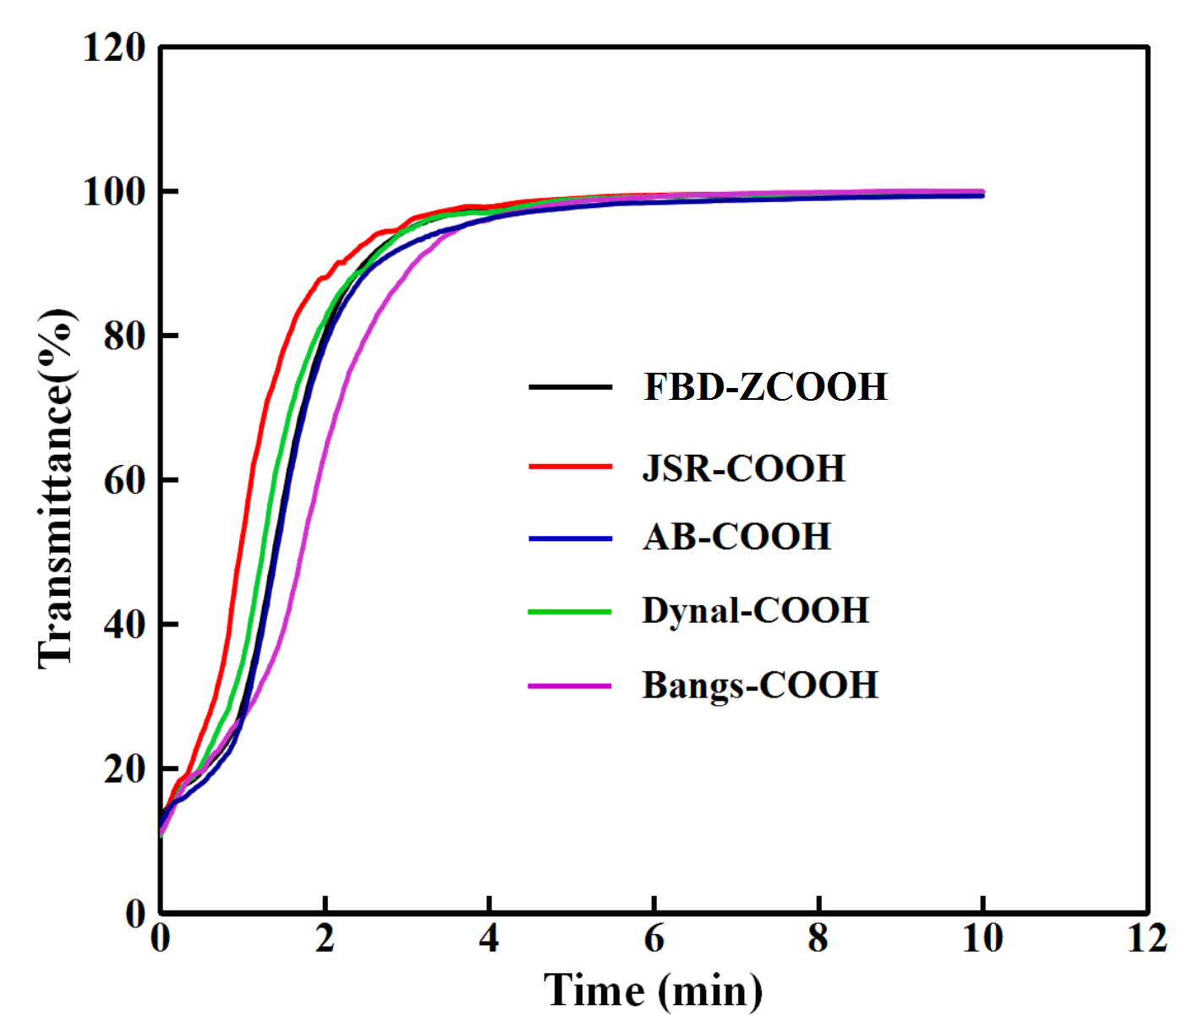
At pH 7.0 in PBS
FBD-MSP-ZCOOH by TEM
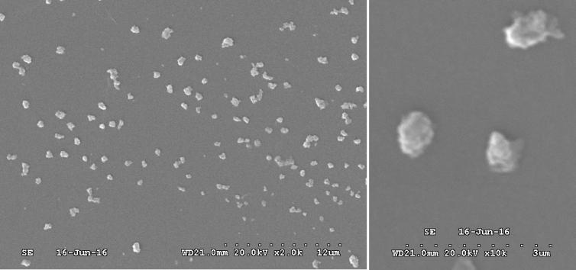
Size (0.66 ± 0.15) μm (n = 98)
Aqueous size
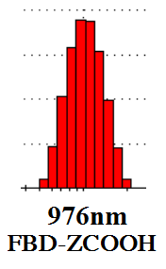
Size ~1.0 μm

Magnetic response rate (time for 95% separation)

MSPFBD- ZCOOHJSR- COOHAB- COOHBangs- COOHDynal- COOHTime (min)3.1 ± 0.23.0 ± 0.23.6 ± 0.23.7 ± 0.23.1 ± 0.2

Effects on common enzymes for chemiluminescence immunoassay

Saturated conjugation of polyclonal antibodies to isolate antigen ECAP

Surface of zwitterions for strong hydrophilicity, Fe₃O₄ nanocores, swelling in water, carboxyl group ~20 μmole/g through long linear arms, streptavidin reserved nearly 75% activity after conjugation

