
FBD-MSP-ZEW for Extraction of Nucleic Acids
Examiner: RDXXX /RDXXX in R&D department; 2016.10.14~10.18; Shanghai Laboratory
- Examination systems
Clinical specimens: cervical exfoliated cells, a total of four samples
Group B: Dynabeads Myone Magnetic Particles Silane
Group A: centrifuge extraction; Group C: FBD-MSP-ZEW
Methods: the standard protocol for qPCR and nucleic acid extraction
Batches: a total of three batches of FBD-MSP-ZEW tested
- Results
Part A. extraction efficacy of nucleic acids
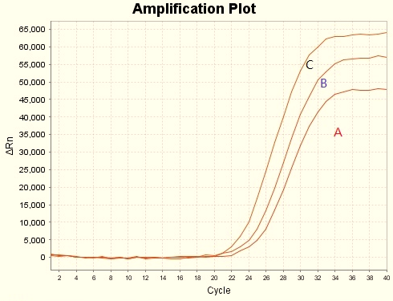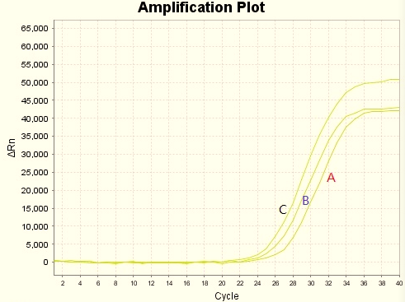
Sample 1 Sample 2
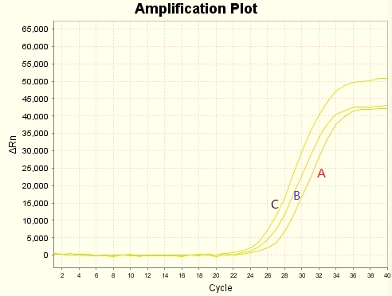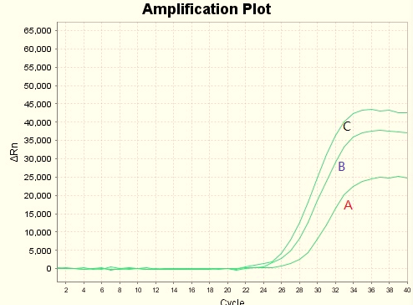
Sample 3 Sample 4
Part B: reproducibility of the sample FBD-MSP-ZEW
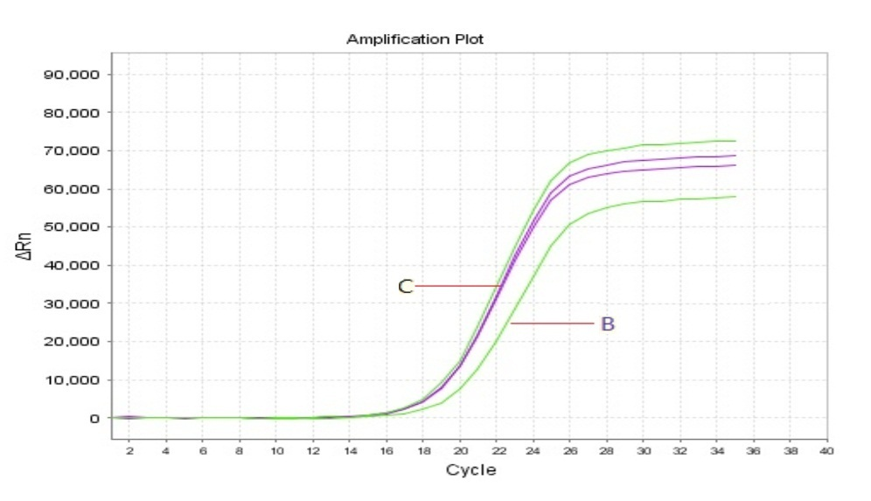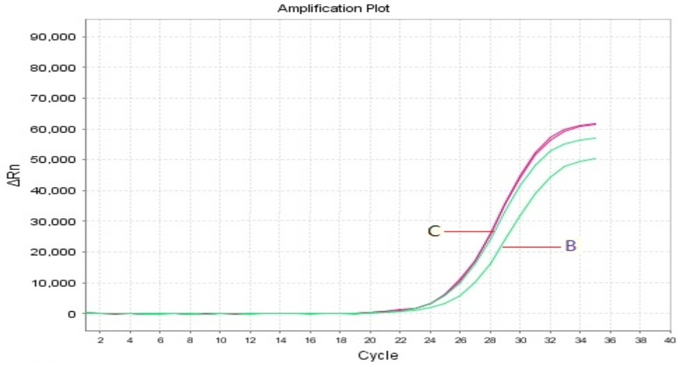
Sample 1 Sample 2
- Conclusion
  - FBD-MSP-ZEW had higher efficacy to extract nucleic acids than Dynabeads Myone Magnetic Particle Silane, both of which were better than the centrifuge extraction.
  - The three batches of FBD-MSP-ZEW gave Ct with CV <5%.
  - FBD-MSP-ZEW has promise for the extraction of nucleic acids in clinical specimens.

